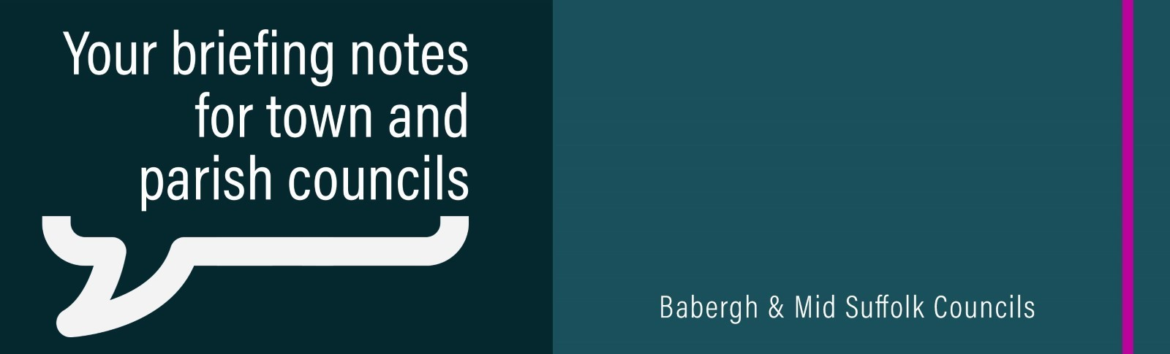

February 2024

Mid Suffolk reveals draft budget to deliver new vision
Tackling climate change and ensuring social justice are at the heart of Mid Suffolk’s District Council’s budget proposals - while limiting council tax increases for residents, the council’s leader has pledged. A proposed council tax rise of 2% in district's share of bill would mean an extra 7p a week for residents.

Plan for ‘transformative’ £18m Skills and Innovation Centre passes milestone
Mid Suffolk District Council’s plan for an £18m Skills and Innovation Centre in Stowmarket has passed a major milestone – with hopes it will be “transformative” for local business, training and jobs.

Flood-threatened communities get emergency plan support
Communities at risk of flooding are being helped by Mid Suffolk District Council to better prepare for the future.

Funding available for community action on climate change
Applications are being invited for The Suffolk Climate Action Community Match Funder. It is available to charities, community interest companies, parish councils, voluntary groups and other not-for-profit organisations, whose projects contribute to Suffolk’s Climate Emergency Plan.

£230,000 awarded to community projects across the districts
Projects across Mid Suffolk and Babergh have received a share of £230,000 in grants and funding as part of the councils’ commitment to residents’ wellbeing and ensuring communities have access to local community facilities.

Councils award funding to provide warm spaces this winter
More than 30 community projects in Mid Suffolk and Babergh have each received a share of more than £36,000 to keep residents warm and connected this winter.

New electric bikes arrive at Needham Lake
Two new electric bikes can now be hired from Needham Lake, helping to encourage sustainable travel.

More Brits overseas can now vote
British citizens living abroad are now eligible to register to vote in UK general elections, regardless of how long they’ve been living outside the UK.

