DEBENHAM PARISH COUNCIL
Email: parish.clerk@debenhamparishcouncil.org
Signed
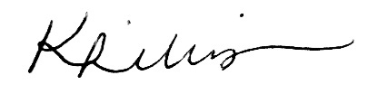
Parish Clerk – 15 November 2025
EMPLOYMENT COMMITTEE
NOTICE OF EXTRAORDINARY MEETING
Members of the Employment Committee are hereby summoned to attend an Extraordinary Meeting to be held on Thursday 20th November, 1pm at Dove Cottage, High Street, Debenham.
Members of the press and public are welcome to attend. However, the Committee may determine to exclude the press and public during the meeting for any items of a confidential nature, as permitted under the Public Bodies (Admission to Meetings) Act 1960.

AGENDA
- Apologies for absence
To receive and approve apologies for absence.
- Declarations of interests
To receive any declarations of pecuniary or non-pecuniary interests in respect of items on this agenda.
- To consider matters relating to the Council’s future staffing arrangements
The Committee may resolve to exclude the press and public for this item due to the confidential nature of the business under the Public Bodies (Admission to Meetings) Act 1960.

