**DEBENHAM PARISH COUNCIL**

**Report on the Solar Panels proposal for the land North and South of the Lakes.**

1. **Purpose of Report:**

Debenham Parish Council recently commissioned a report entitled “The future of renewable energy in Debenham – A Community Vision”.

The purpose of this report is to seek Parish Council approval and funding of up to £1,000 to explore the community’s views on whether and how to turn the vision into reality.

1. **Background:**

With both Suffolk County Council and Mid Suffolk District Council declaring ‘Climate Emergencies’ coupled with the energy crisis that the UK is facing it was felt to be an opportune time to look at the options for ‘green energy’ for Debenham.

Council will recall that investigations have been approved to take place regarding the installation of ground mounted Solar Panels on the fields to the north and south of the Woodland lake. Both parcels of land are leased by the Parish Council from Suffolk County Council on a 999 year lease that commenced in 2004.

Both parcels of land are of archaeological interest so will require an archaeological survey to be carried out before any works can commence. Such surveys should not, however, prevent any development from happening.

In June 2022 it was established that grid connectivity could be obtained for the site, albeit with a marked curtailment on the license.

In partnership with the Suffolk Preservation Society (SPS), who were working with the Campaign for the Protection of Rural England (CPRE), a series of 3 ‘Energy Visioning’ workshops were held in September/October 2022. There were on average 20 attendees at each workshop where the options and possibilities of ‘Green Energy’ were explored. The workshops were enthusiastically in support of developing green energy for Debenham. The aspiration being for Debenham to be 100% self sufficient with energy production as soon as possible.

1. **Why these two sites?**

One of the clear messages to come out of the SPS workshops was that any development should take place on council owned land and have a straightforward grid connection. The above two sites are the only land that the parish council has influence over. That being the case, the council will have control over the benefits that can be fed back into the village. This meets the third criteria set down in the workshops.

These two sites come under the Agricultural Land Classification (ALC) scheme as category 3a and 3b (Good quality agricultural land to Moderate quality agricultural land). The ALC for the Debenham area is a broad-brush approach which covers all the fields in an area. Closer examination of the two sites, and discussions with the local tenant farmer, indicate that the ALC should be grade 4 for the two sites (Poor quality agricultural land) as the sites are poor quality pasture land and have been for the last 30 years or more. Sheep have grazed the area off and on over that period. The proposed scheme will allow sheep to continue to graze the land once the panels are installed, so no loss of agricultural use will occur.

The test of not using the Best Most Versatile (BMV) land for solar panels has been passed in this case.

The map below shows the extent (edged in blue) of the development on the two fields.

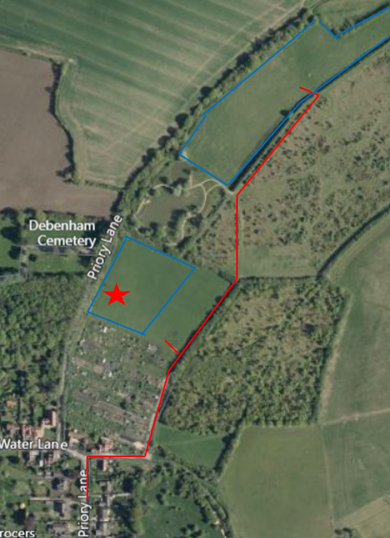

The red line indicates the access to the sites and the red star is the approximate grid connection point.

The field to the north of the lake is almost completely shielded from view by thick hedges and trees, particularly on the east, north and western boundaries. A hedge, similar to the eastern boundary hedge could be planted on the currently exposed southern boundary to mitigate the visual impact from the view direction. Appendix A shows some visualisations of the views from the woodland area.

Although the initial thoughts were to not include the field to the south of the lake in the development, the grid connection point being located in the south field means it makes sense to include part of the south field in the development.

Care has been taken to avoid spoiling the ‘much valued’ view from the top of the cinder track (to the east of the south field) that looks back into the village towards the church. This southern field plateaus near the cinder track and then slopes away down towards Priory Lane. The upper plateau section is left untouched by the development so that the view into the village is unspoilt. The lower slope can be shielded with hedge planting to soften the view of the panels and associated infrastructure.

1. **The proposed installation:**

The two sites together comprise some 2.75ha of land (6.5 acres) which should enable something in the region of a 1.3 to 1.9MWh solar farm to be installed. The variation is because of the unknown factors regarding capacity of panels available and the exact layout of the site still to be determined.

The ‘curtailment’ previously mentioned that would be imposed on the grid connection license can be mitigated to a large degree by using battery storage in conjunction with the solar panels. The 46% curtailment means that we can only ever export 54% of what is produced at any one time. Metering and control systems put in place would limit the day time output (when the solar panels are active) to be only 54% of total capacity. The remaining output would feed into the battery store and this energy released in to the grid at night (when the panels are not active). In such a way the total output from the panels is utilised and we do not exceed the 54% output restriction.[1]

There would be minimal disturbance to the ground when the panels are installed as screw-in foundation piles would be used. (These can be unscrewed at the end of the project life).



*Fig 1. Screw piles being installed.*

The short lengths of foundation protruding above the ground have the steel frames that the panels are mounted on, bolted into the foundations. All are regarded as a ‘semi-permanent’ structure.

Where metering equipment, control gear and batteries are housed, in purpose made shipping containers, these would require a bunded concrete hard standing area. This area would cover a very small area of the total land used. The bunded area would contain any leakages from the batteries or control gear.

Due to accessibility requirements the metering, control gear and batteries would need to be housed in the south field, probably on the eastern boundary line to maximise the distance from the nearest properties. Maintenance vehicles must have clear access to such sites which makes the north field unsuitable.

1. **Likely Costs and Potential Income.**

The proposal will incur initial capital costs of £1,500,000 which would need to be funded by a Public Works Loan Board loan to be repaid over an agreed term of possibly 10 or 15 years. Repaying over 10 years at todays interest rates would cost £183,000 per annum.

The potential income from the proposed installation would be in excess of £9m over 30 years.

1. **Next Steps:**

While there was huge enthusiasm expressed for ‘green energy’ at the 3 workshops, the whole village must, in my opinion, be given the opportunity to approve (or not) the proposals. There needs to be a professional feasibility study carried out to determine if the proposals are totally sound. That will require funding that grants can cover. However, the grants will not be forthcoming unless the community backs the proposals.

1. **Recommendations:**

The Parish Council are asked to approve:

* 1. That TWO Parish Council public meetings are arranged to allow residents to review the proposals and either show support, or not, for such proposals to progress. Two meetings are suggested in case some people cannot attend one or other of the meetings. I am willing to host the public meetings. The £1,000 mentioned earlier is required to cover the costs of the meetings.
  2. That subject to approval being achieved at a) above, authority be given to the Solar Panel working group to prepare and submit grant applications for a feasibility study to be undertaken.
  3. That subject to a) and b) being approved that the solar panel working group prepare a detailed specification for the feasibility study.
  4. That the outcome of a) and the progress of b) and c) are reported back to the Parish Council on a regular basis.
  5. That the Solar Panel working group continue to explore the options available in this fast developing technology field.

**APPENDIX A:**

Illustrations of how the visual impact on the North field could look like. The following illustrations are purely to show how the visual impact can be mitigated with screening. The illustrations are not necessarily what the final proposal will actually look like.

1. Site Location Plan.

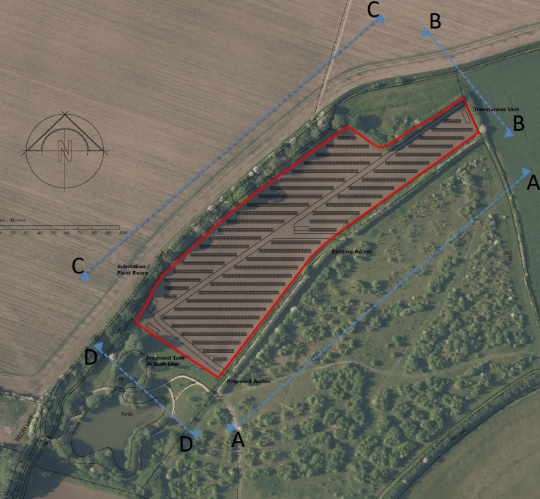

Showing section lines AA – DD in plan

1. Existing Site.

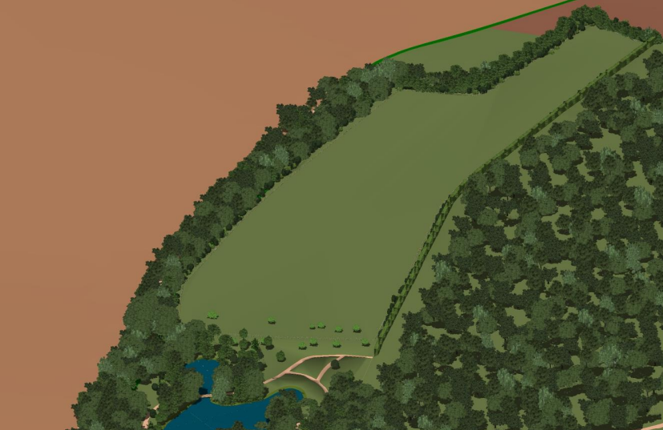

1. Proposed Site.

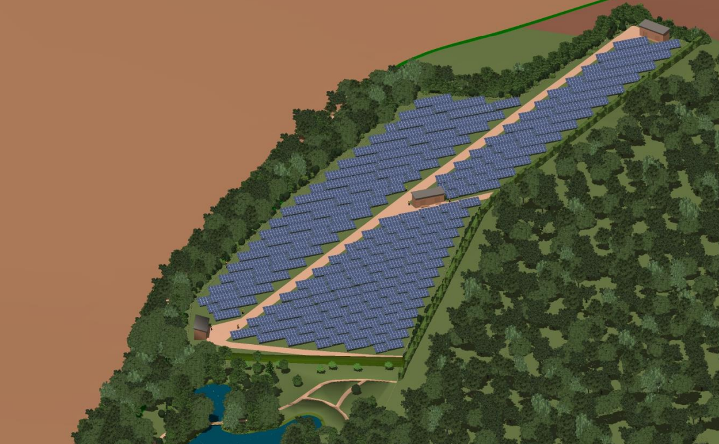

1. Site Sections A-A; B-B; C-C and D-D.

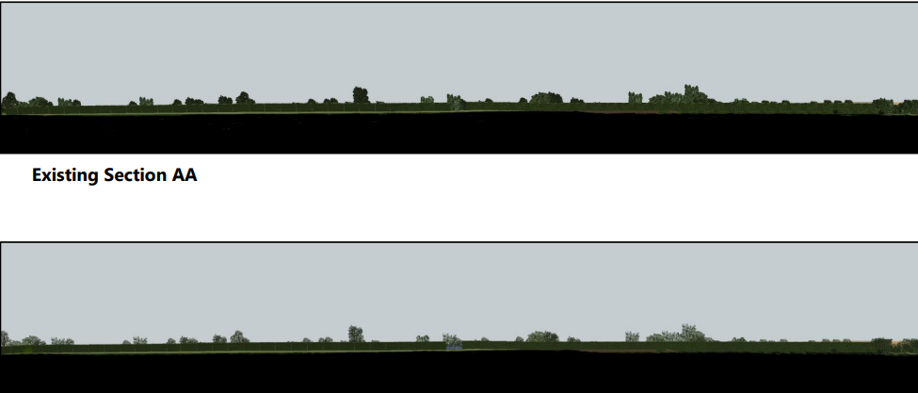

Proposed section A-A (Eastern boundary) – solar panels visible at entrance to field.

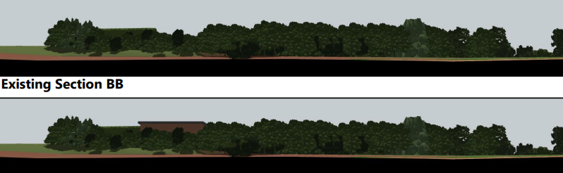

Proposed section B-B (Northern boundary) showing possible building location.

Proposed section C – C (Western boundary) with occasional sighting of panels.

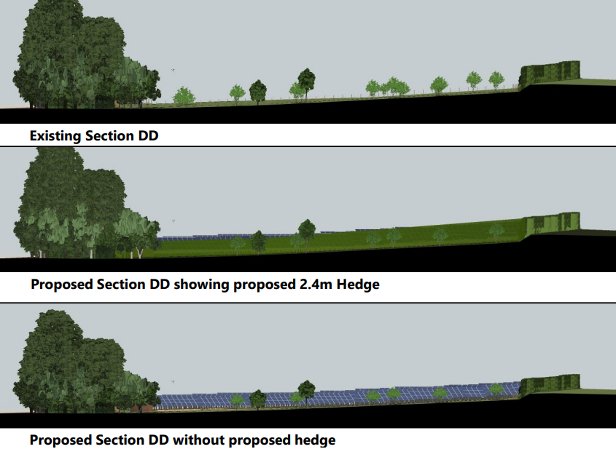

The following photos and illustrations try to show what the field will look like from various viewpoints.

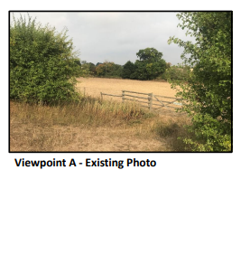

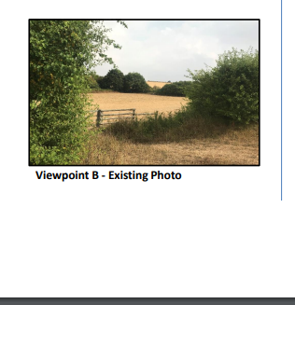

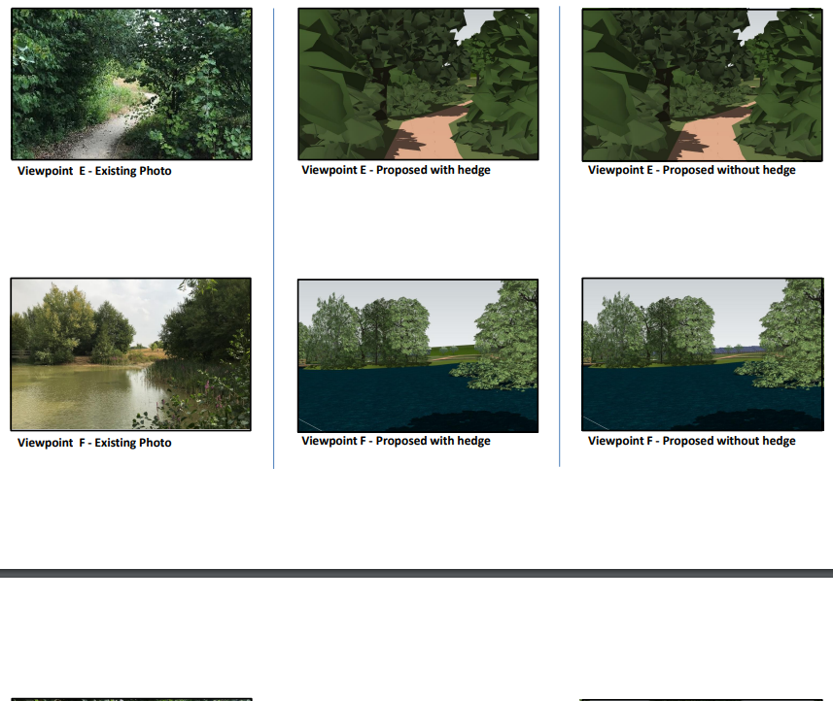

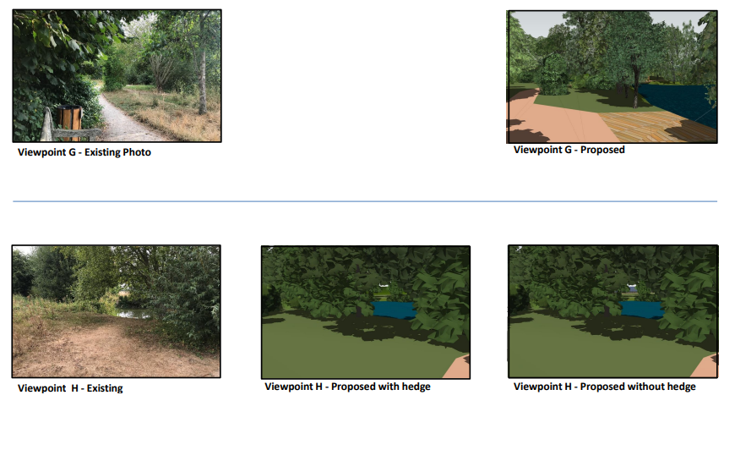

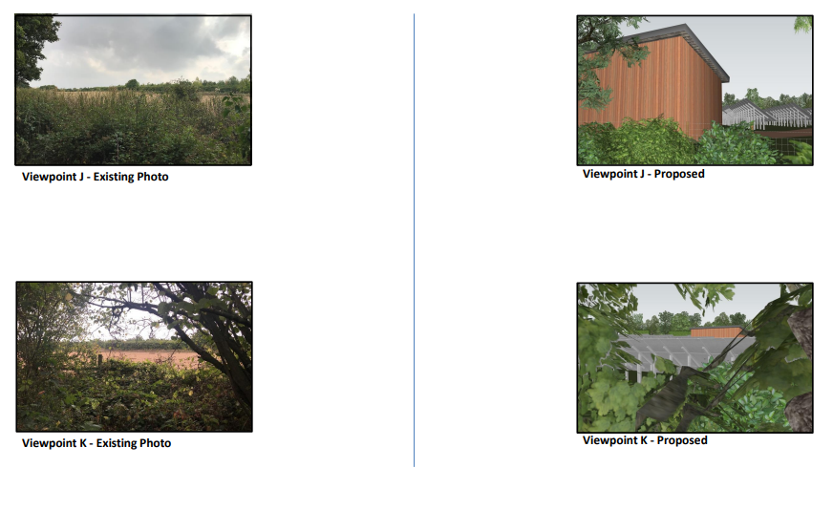

An illustrative view within the proposed site after completion.

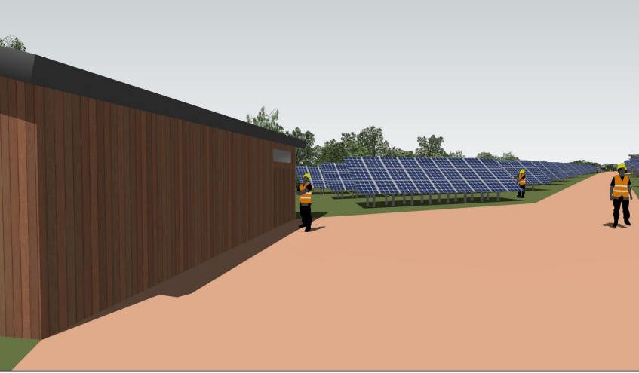

1. With the introduction of the new powerlines (East Anglia Green) feeding the North Sea wind turbine power through the area to London comes an upgrade to the local power network which could mean that these sorts of curtailments are removed.