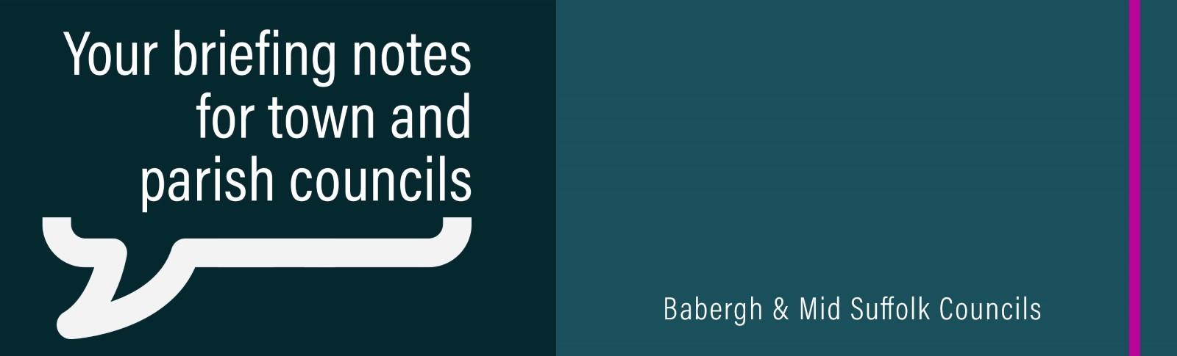

November 2023

Help shape the future of the Babergh and Mid Suffolk districts
Our consultation continues on what matters most to our communities in order to help shape future plans. Find out more.

Flood support
Emergency council teams worked to support areas impacted by floods last week in the wake of Storm Babet, offering practical support, as well as information and advice on what to do if your home or business was affected. Find out more.

We also paid tribute to our local heroes and the huge show of community spirit following the worst flooding for years in our districts. Find out more.

Your new council website
Last month saw the launch of our new council website, and we are keen for your feedback on our new look. Find out more.

£1.3m boost for Babergh and Mid Suffolk communities
Town and parish councils in Babergh and Mid Suffolk received more than £1.3 million in developer contributions last month. Find out more.

Pride in Your Place – deadline extended
The deadline for applications for Mid Suffolk District Council's 'Pride in Your Place' grant has been extended.

Towns and parishes across the district now have a further month to apply, with the deadline extended to November 30.
This will allow even more parishes to take advantage of the funding for projects to improve the appearance and cleanliness of their communities, particularly in the wake of recent storm damage across the district.

More information about the campaign and an application form can be found on the council's website.

Transport grants to better connect rural communities
A new grants scheme was agreed last month to increase community transport options, better connect local communities, and reduce emissions. Find out more.

Suffolk councils delivering project to improve private rented housing sector
‘Safe Suffolk Renters’ is an initiative to support private sector tenants, landlords and other stakeholders. Find out more.

Councils’ set out commitment to increase EV chargers
Babergh and Mid Suffolk agreed to implement a new joint Electric Vehicle (EV) Infrastructure Implementation Plan. Find out more.

Free net zero advice for Suffolk businesses and organisations
The councils partnered with an environment charity to deliver expert energy advice to businesses. Find out more.

Have your say on polling arrangements
Councils are asking residents for feedback on polling districts and places across the county. Find out more.

How we supported families over Halloween half term
The councils staged a range of holiday activities to keep youngsters active and entertained during half term. Find out more.

Major expansion of iconic John Peel Centre hits new phase
Works to expand the John Peel Centre stepped up a gear last month, allowing it to stage even more music, events and entertainment and support Stowmarket town centre’s economic and cultural growth. Find out more.

Local children share their vision of ‘homes in future’
Eye schoolchildren shared their visions of ‘homes in future’ last month to celebrate the transformation of a former care home into affordable housing. Find out more.

