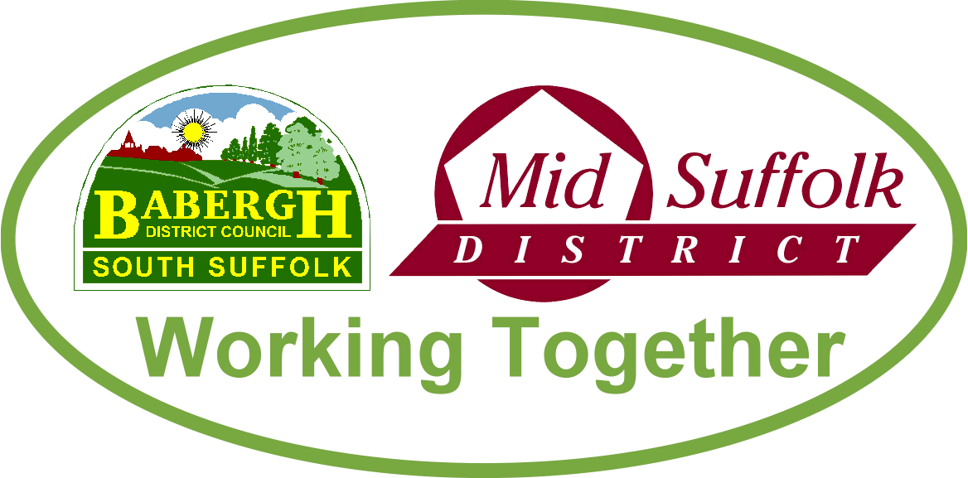

September 2022

How your council can help you with the cost of living
Support packages to combat the cost of living, energy bills and council tax are all available through Babergh and Mid Suffolk District Councils, with residents urged to check they are receiving the support they are entitled to. More information

Councils set to lead the way in transforming tree planting for generations
Tree coverage across Babergh and Mid Suffolk is set to increase to help tackle biodiversity loss and climate change, after a pioneering council-commissioned tree canopy survey identified key planting locations and significant benefits. More information

New parents again invited to apply for a free tree
Babergh and Mid Suffolk’s popular Tree for Life scheme, which offers a free tree for new parents, is open once again for 2022 applications. More information

Don’t lose your vote – residents across the districts urged to check their voter registration details
Babergh and Mid Suffolk District Councils have started the Annual Canvass of Electors and are asking residents to check the electoral registration details for everyone eligible to vote at their address. More information

Find out ‘What’s Next for Stowmarket’ at public exhibition
A new pop-up exhibition coming to Stowmarket from Thursday 22 September to Saturday 24 September at the town’s John Peel Centre will showcase a range of projects and proposals that will shape the future of the town. More information

…including Stowmarket wellbeing and leisure hub
Residents, community groups and sports clubs are being invited to have their say on the development of plans for new leisure, health and wellbeing facilities in Stowmarket. More information

Switch onto the Digital Skills Programme for businesses
Business owners in Babergh and Mid Suffolk can take advantage of free workshops to help boost their confidence online by accessing the Councils’ Digital Skills Programme. More information

Simple scheme to buy solar panels returns for Suffolk residents
Solar Together Suffolk, a group-buying scheme which has helped over 1,500 homes in Suffolk to install solar panels and batteries, is now open for new registrations. More information

Suffolk Waste Partnership backs national campaign to raise awareness of safe battery disposal
Suffolk Waste Partnership is backing a nationwide campaign urging people to safely dispose of old batteries in a bid to avoid starting fires in refuse vehicles and waste processing facilities. More information

Putting Suffolk on the big screen
Babergh and Mid Suffolk leaders have joined colleagues from across the county to agree steps to continue to attract filmmakers to the region – putting Suffolk on the big screen and bringing in millions to the local economy. More information

Councils awarded £60k for gum busting clean up
West Suffolk Council and Babergh and Mid Suffolk District Councils are among the first of 40 council areas to receive cash from chewing gum manufacturers to help remove gum from the street. More information

Event to explore NHS career opportunities
A careers event in Stowmarket last month helped showcase the vast range of career paths available within the NHS for local youngsters. More information

