

Hoppit Woodland & Lake
Management Plan

Author: Kevin Voller

Date: 04/10/09

Version: c

Status: Draft

Table of Contents

1. Table of Contents 2
2. Introduction 3
3. History 4
4. Management Principles 5
5. Maintenance Schedule Lake and Surrounding Area 6
6. Lake 7
7. Fish 10
8. Woodland 11
9. Wildflower Meadow 15
10. Map of Woodland & Lake 18
11. Child Protection Code of Conduct 20
12. Health and Safety 21
Risk Assessments 21
Schools and visiting parties 21
School activities within the school grounds 21
Site safety 21
Health & Safety Demos 22
First Aid 22
Children and Young People on site 22
13. Amendment Record 23
14. Document Review 24

Figure 1 - Lake Planting 7
Figure 2 – Map of Wood and Lake 18
Figure 3 – Tree Planting 19

Introduction

This management plan sets out the aims and goals for the Debenham Hoppit woodland and lake.

The plan will be broken down into two main areas:

- Lake and surrounding area
- Woodland

Each area will be documented separately.

History

The project is managed by a Steering Committee established in May 2003 following a public meeting, which was part of a wider community consultation exercise carried out under the Market Towns Initiative Programme. The Committee comprises local residents, Parish Councillors, and the Greenlight Trust (an environmental organisation involved with the development of community woodlands). The Committee has a constitution and formal agreements in place with the Parish Council and the Greenlight Trust.

The site (approx 25 acres) which is formerly leased from Suffolk County Council (on a 999 year lease) in October 2005.

The site will consist of:

  - Lake (approx 1 acre)
  - Woodland planting (approx 12 acres)

The land was previously farmed by the Durie partners (predominately wheat).

September 2004 Lake site cleared and excavation work commenced
November 2004 1st mass tree planting session – 1100 trees planted
February 2005 Hedge planting
February 2005 Lake completed filling after heavy snow fall
June 2005 Official woodland opening
May 2005 Market Town Initiative Award
August 2005 First newts spotted in lake
November 2005 2nd mass tree planting – 1000 trees planted
November 2005 1000 plus fish released into lake
November 2006 3rd mass tree planting – 1000 trees planted
October 2007 7 bales of hay from the Suffolk Wildlife Trust’s Martin's Meadow were collected from Foxburrough Farm and strewn over part of the area designated for the wildflower meadow.
November 2007 Woodland edge planting – 330 trees/shrubs
March 2008 300 wildflower plug plants
November 2008 20 Apples trees
November 2008 200 hedge plants
November 2008 3 Black Poplars
February 2010 20 Apple trees
February 2011 840 Hedge Plants (Debenham Scouts plus SRH)

Management Principles

Here we plan to set out the management principles for the different areas.

Management Aims:

  - Influencing the ecological succession of the site to preserve and increase its wildlife value.
  - To create more habitat.
  - To provide an amenity for passive and active recreation.
  - To provide an educational resource.
  - To provide woodland products from coppicing etc.
  - To provide an angling facility within the village.

Maintenance Schedule Lake and Surrounding Area

Grass Cutting schedule:

To be agreed

Mulching

Annual or whenever required.

Note:

Management work can be very destructive to amphibians if carried out at the wrong time of year. Aquatic weed control and other sever disturbance should be avoided during the breeding season.

Name | Hibernation | Mating and spawning | Tadpoles leaving water
Smooth newt | mid October – end Feb | early March – early June | Late June – mid October
Common frog | Mid October – end Feb | early March – end April | End May – mid August
Common toad | Mid October – mid March | mid March – end April | late May – late July

Lake

Lake Area Planting

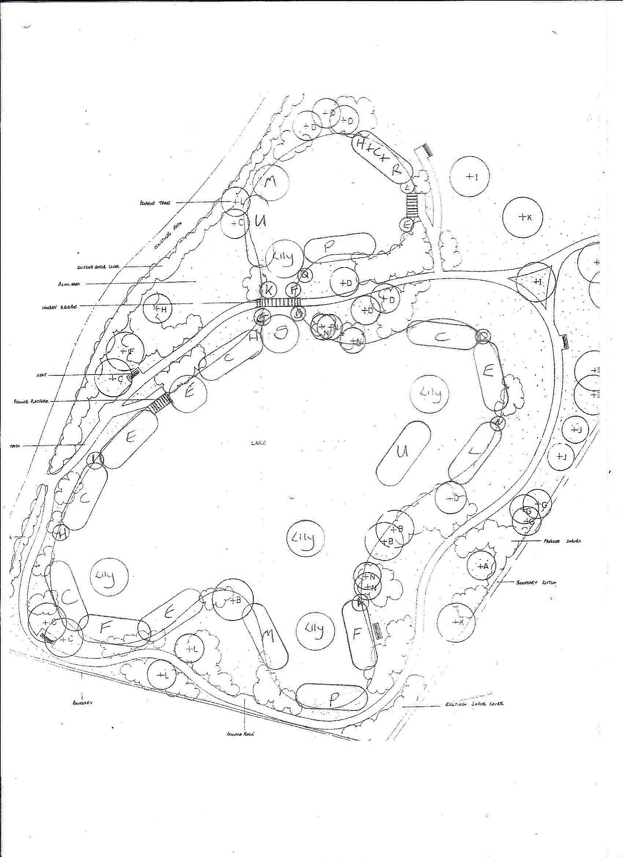

Figure 1 - Lake Planting

Key to planting

Area on Diagram | Plant | Quantity | Planting Depth | Height
 | Shallow (10 plants per square metre - marginals
A | Alisma plantago-aquatica (Water plantain) | 10 | 40cm | Tall
B | Butomus umbellatus (Flowering rush) | 40 | 50cm | Tall
C | Caltha palustris (Marsh marigold) | 500 | 20cm | Medium
D | Eleocharis palustris (Common spike rush) | 10 | 30cm | Medium
E | Iris pseudaeorus (Yellow flag iris) | 300 | 30cm | Tall
F | Lythrum salicaria (Purple loosestrife) | 300 | 30cm | Tall
G | Mentha aquatica (Water mint) | 30 | 30cm | Low
H | Myosotis scorpoides (Water forget me not) | 100 | 10cm | Low
 | Marsh/edge (10 plants per square metre - marginals)
I | Aquilega vulgaris (Columbine) | 30 |  | Tall
C | Caltha palustris (Marsh marigold) | 200 | 20cm | Medium
K | Carex obtrubae (Fox sedge) | 10 |  | Tall
L | Filipendula ulmaria (Meadow sweet) | 50 |  | Tall
M | Glyceria maxima (Reed sweet grass) | 100 | 20cm | Very Tall
N | Guem rivale (Water avens) | 30 |  | Short/shady
E | Iris pseudaeorus (Yellow flag iris) | 500 | 30cm | Tall
P | Juncus effusus (Soft rush) | 200 | 5cm | Medium
Q | Lysimachia nummularia (Creeping jenny | 40 | 10cm | Low
R | Veronica beccabunga (Brooklime) | 50 | 10cm | Low
 | Deep water (Oxygenators 5 plants per square metre)
S | Hottonia palustris (Water violet) | 100 | 60cm | 80cm
T | Ceratophyllum demersum | 200 | 80cm
U | Hippuris vulgaris | 100 | 2m
 | Floating (Lilies in groups of 3)
Lily | Nymphaea alba (White water lily) | 15 buckets | 2m
W | Stratiodes aloides (Water soldiers) | 100

Specimen Tree Planting

Area on Diagram | Plant | Number | Size
A | Malus Sylvestris (Crab Apple) | 1 | 1.5/1.8m
B | Salix fragulus (Crack Willow) | 3 | 1.22/1.5m
C | Alnus glutinosa (Alder) | 4 | Std 6 – 8
D | Populus alba (White Poplar) | 7 | 1.8m
E | Quercus robur (Oak) | 2 | Std 8-10
F | Carpinus betulus (Hornbeam) | 1 | Std 8-10
G | Betula pendula (Silver Birch) | 3 | 1.8m
H | Sorbus aria (Common Whitebeam) | 1 | Std 8-10
I | Aesculus hippocasranum (Horse Chestnut) | 4 | 60-90
J | Tilia cordata (Small leaved lime) | 2 | Std 8-10
K | Fraxinus excelsior (Ash) | 2 | 90-120
L | Crataegus monogyna (Hawthorn) | 3 | 120-150
M | Populus nigra (Black Poplar) | 2 | 150-180
N | Salix Caprea (Goat Willow) | Not available
Supplier – Nimbus Trees(South Lopham, Diss)
Planting date :26 – 28 November 2004
As per diagram

Shrub Planting

Plants | Percentage
Euonymus euapaeus (Spindle berry) | 10%
Sambucus nigra (Elder) | 10%
Cornus sanguinea (Dogwood) | 30%
Viburnum opulus (Guilder Rose) | 10%
Salix caprea (Goat Willow) | 20%
Corylus avellana (Hazel) | 20%
Rosa carnina (Dogrose) | 10
Frangula alnus (Alder Blackthorn)) | 30%
Alnus glutinosa (Alder) | 20%
The percentage-planting rate refers to the whole site; each individual shrub area need not include all the species specified. The majority of shrubs of the same species should be grouped together in 3s and 5s with some individual planting. Shrubs to be planted with a typical plant spacing of 1meter, tree species to be coppiced at 5m spacing.

Grass

It is suggested the seed mix used is:

For amenity areas that are cut:

Plant | Percentage by weight
Chewings Fescue | 60
Creeping Red Fescue | 10
Crested dogs-tail | 10
Smooth Meadow grass | 10
Browntop Bent | 10

Low maintenance grass mixture for areas requiring little or no cutting:

Plant | Percentage by weight
Chewings Fescue “Koket/Mary | 20
Fine leaved sheeps fescue “Fritalia/ Barok | 20
Hard Fescue “Biljart/ Cristal | 25
Slender creeping red fescue “Dawson/ artist | 30
Browntop Bent “Highland | 5

Fish

Fish Type | Number | Size
Roach | 600 | 4 – 8 inch
Carp | 35 | 10inch – 5lb
Carp | 10 | 8 – 10 inch
Carp | 32 | 6 – 8 inch
Tench | 5 | 1lb
Tench | 15 | 8 – 10 inch
Tench | 78 | 6 – 8 inch
Supplier :
Tom Harbinson
Coarse Fish Farmer
Hall Lodge
Brettenham
Ipswich
Suffolk
IP7 7QP
Release date :26th November 2005

Extract from BTCV handbook “Waterways & Wetlands”
Suitable species for introduction to new ponds include :
- Carp (Cyprinus carpio). These are bottom feeders which do not spawn in most waters in this country. This is an advantage in new ponds because it gives other aquatic organisms a better chance to develop.
- Tench (Tinca tinca). These are bottom feeders which, like carp, sift the mud, but take different food and so do not compete with carp.
- Roach (Rutilus rutilus), which feed on algae, plant fragments and insects among the beds of aquatic plants. Roach often over-breed but the surplus can be netted.

Coarse fish depend on higher water temperatures for spawning than do game fish, and so spawn later, mostly in May and June. The ova, which in most species are deposited on underwater plants, wood or among stones, only take from several days to a fortnight to develop, depending on the species and water temperature

Woodland

Woodland Trees 1st Planting

Plant | Number | Size
OAK,ENGLISH | 600 | B/R 40-60CM
ASH | 160 | B/R 40-60CM
HORNBEAM | 120 | B/R 40-60CM
MAPLE,FIELD | 120 | B/R 40-60CM
Supplier - BTCV
Planting date :26 – 28 November 2004
Planting Schedule
Clumps of 25 trees comprising
15 x English Oaks
4 x Ash
3 x Hornbeam
3 x Field Maple

Woodland Edge Shrubs (1ST planting)

Plant | Number | Size
CRAB APPLE | 3 | B/R 40-60CM
WILD PEAR | 3 | B/R 40-60CM
HAZEL | 40 | B/R 40-60CM
GUELDER ROSE | 20 | B/R 40-60CM
DOG ROSE | 20 | B/R 40-60CM
DOGWOOD | 20 | B/R 40-60CM
HAWTHORN | 20 | B/R 40-60CM
Supplier - BTCV
Planting date :26 – 28 November 2004
Randomly Planted around woodland edges

Woodland Trees 2nd Planting

Plant | Number | Size
OAK,ENGLISH | 600 | B/R 40-60CM
ASH | 160 | B/R 40-60CM
HORNBEAM | 120 | B/R 40-60CM
MAPLE,FIELD | 120 | B/R 40-60CM
Supplier –
Moleson Ltd
Tel: 01379 852728
Mobile: 07899 901182
Contact: Andrew Long
Planting date :25 – 27th November 2005
Planting Schedule
Clumps of 25 trees comprising
15 x English Oaks
4 x Ash
3 x Hornbeam
3 x Field Maple

Woodland Edge Shrubs (2nd planting)

Plant | Number | Size
CRAB APPLE | 3 | B/R 40-60CM
WILD PEAR | 3 | B/R 40-60CM
SPINDLE | 4
HAZEL | 40 | B/R 40-60CM
GUELDER ROSE | 20 | B/R 40-60CM
DOG ROSE | 20 | B/R 40-60CM
DOGWOOD | 20 | B/R 40-60CM
HAWTHORN | 20 | B/R 40-60CM
Supplier –
Moleson Ltd
Tel: 01379 852728
Mobile: 07899 901182
Contact: Andrew Long
Planting date :xx February 2006
Randomly Planted around woodland edges

Woodland Trees 3rd Planting

Plant | Number | Size
OAK,ENGLISH | 600 | B/R 40-60CM
ASH | 160 | B/R 40-60CM
HORNBEAM | 120 | B/R 40-60CM
MAPLE,FIELD | 120 | B/R 40-60CM
Supplier –
Moleson Ltd
Tel: 01379 852728
Mobile: 07899 901182
Contact: Andrew Long
Planting date :24 – 26th November 2006
Planting Schedule
Clumps of 25 trees comprising
15 x English Oaks
4 x Ash
3 x Hornbeam
3 x Field Maple

Woodland Edge Shrubs (3rd planting)

Plant | Number | Size
CRAB APPLE | 3 | B/R 40-60CM
WILD PEAR | 3 | B/R 40-60CM
SPINDLE | 4
HAZEL | 40 | B/R 40-60CM
GUELDER ROSE | 20 | B/R 40-60CM
DOG ROSE | 20 | B/R 40-60CM
DOGWOOD | 20 | B/R 40-60CM
HAWTHORN | 20 | B/R 40-60CM
Supplier –
Moleson Ltd
Tel: 01379 852728
Mobile: 07899 901182
Contact: Andrew Long
Planting date :14th January 2007
Randomly Planted around woodland edges

Woodland hedge

Plant | Number | Size
BLACKTHORN | 5 | B/R 40-60CM
FIELD MAPLE | 5 | B/R 40-60CM
HAZEL | 5 | B/R 40-60CM
GUELDER ROSE | 5 | B/R 40-60CM
ROSE,DOG | 5 | B/R 40-60CM
HAWTHORN | 25 | B/R 40-60CM
Supplier - BTCV
Planting date :xx – xx February 2005
Planting Schedule:
HEDGEROW COLLECTION - 50 BARE ROOTED TREES. SIZE 40-60CM For those planning a hedge the BTCV have put together a collection of those species commonly found in the wild. 50 plants will create a double hedge 10m long or 24m if planted in a single line. The collection contains 25 Hawthorn 5 Blackthorn 5 Hazel 5 Field Maple 5 Dog Rose 5 Guelder Rose.

Planted 22 packs of 50 - 1100

Woodland Edge Shrubs (4th planting)

Plant | Number | Size
CRAB APPLE | 9 | B/R 40-60CM
WILD PEAR | 9 | B/R 40-60CM
SPINDLE | 12
HAZEL | 120 | B/R 40-60CM
GUELDER ROSE | 60 | B/R 40-60CM
DOG ROSE | 60 | B/R 40-60CM
DOGWOOD | 60 | B/R 40-60CM
Supplier –
Moleson Ltd
Tel: 01379 852728
Mobile: 07899 901182
Contact: Andrew Long
Planting date :24th November 2007
Randomly Planted around woodland edges

Specimen Trees

Plant | Number | Size
ALDER | 1 | 1.2/1.5m
ASH | 1 | 1.2/1.5m
ASPEN | 1 | 1.2/1.5m
HORNBEAM | 1 | 1.2/1.5m
LIME (SMALL LEAFED) | 1 | 1.2/1.5m
GREY POPLAR | 1 | 1.2/1.5m
BLACK POPLAR | 1 | 1.2/1.5m
WHITE POPLAR | 1 | 1.2/1.5m
YEW | 1 | 1.2/1.5m
BIRD CHERRY | 1 | 1.2/1.5m
WILD CHERRY | 1 | 1.2/1.5m
HOLLY | 1 | 1.2/1.5m
Supplier –
Moleson Ltd
Tel: 01379 852728
Mobile: 07899 901182
Contact: Andrew Long
Planting Date: Feb 2005
Randomly Planted around woodland edges

Woodland hedge (2008)

Plant | Number | Size
BLACKTHORN | 20 | B/R 40-60CM
FIELD MAPLE | 20 | B/R 40-60CM
HAZEL | 20 | B/R 40-60CM
GUELDER ROSE | 20 | B/R 40-60CM
ROSE,DOG | 20 | B/R 40-60CM
HAWTHORN | 100 | B/R 40-60CM
Supplier - Moleson Ltd
Tel: 01379 852728
Mobile: 07899 901182
Contact: Andrew Long
Planting date : November 2008
Planting Schedule:
HEDGEROW COLLECTION - 50 BARE ROOTED TREES. SIZE 40-60CM For those planning a hedge the BTCV have put together a collection of those species commonly found in the wild. 50 plants will create a double hedge 10m long or 24m if planted in a single line. The collection contains 25 Hawthorn 5 Blackthorn 5 Hazel 5 Field Maple 5 Dog Rose 5 Guelder Rose.

Orchard November 2008

Variety | History
Lady Henniker  (Dual Purpose) | Raised from a seedling, between 1840-50, having been found in discarded cider must at the Henniker family home at Thornham Hall, near Eye. Introduced by head gardener Mr Perkins in 1873. RHS First Class Certificate 1875. Became a popular garden variety. Distinctively oblong and 'slab-sided' in shape, and can be large. Cooks to pale yellow quite strongly flavoured puree, hardly needing extra sugar.
Cartherine  (Culinary) | A late-flowering, long- keeping cooking apple from the garden of the former public house the ‘Live And Let Live’ in Combs, near Stowmarket. Keeps shape well when cooked and more sweet than acidic in taste. Received at the National Fruit Collection in 1977 when the tree was already believed to be a century old.  Ibrahim, Xavier, Oliver Dayhard  Courtney, Charlotte, Carah, Annabel
Clopton Red  (Dessert) | A seedling grown from a Cox's Orange Pippin raised by Justin Brooke of Wickhambrook Nurseries in 1946. Introduced commercially in 1961. A medium sized heavy cropper. Bright red flush. A sweet juicy apple with a delicate aromatic flavour.
Honey Pippin  (Dessert) | A Cox-like variety submitted to the National Fruit Collection in 1981. Developed by Justin Brooke of Wickhambrook Nurseries in the 1950s. Better disease resistance than true Cox. Quite pearmain shaped. Honeyed, sweet, juicy, crisp almost yellow flesh.  Charlie, Will, Peter  Alfie, Christian, Oliver Squirel  Alice, Chloe
Red Miller's Seedling  (Dessert) | A red 'sport' of the Berkshire apple Miller's Seedling, which arose in the garden of Mr. Wheldon, of Sudbury, sometime before 1948. A small conical fruit that is easily bruised, with crisp, very juicy sweet flesh.  Jack, James, Chris, William Rocket
Old Blake  (Culinary) | A late-keeping yellowish green skinned cooking apple still grown in and around Blundeston near Lowestoft. It is believed to have arisen at the Old Forge in the 1800s. Pinkish flesh when cooked with low acidity.  Alfie, Luke & Liam  Rodrie, Henry, George
Maxton  (Dessert) | A more highly coloured 'sport' of the Bedfordshire apple Laxton's Superb with the added advantage of non- biennial cropping. Discovered in an orchard at Assington in 1939. Sent for trial in the National Fruit collection in 1961 and later in the 1960s to Holland, where it was known as Suffolk Superb. Sweet, finely textured, quite juicy flesh and more highly coloured than Laxton's Superb. Has good canker and mildew resistance.  Rosie, Charlotte, Jade  Lorna
Lord Stradbroke  (Culinary) | Found, or raised, by Lord Stradbroke's head gardener, Mr Fenn, at Henham Hall, near Wangford, in about 1900. RHS Award of Merit in 1905. Synonyms include Fenn's Wonder and Fenn's Seedling. Large and maroon in colour, prominently ribbed and crowned. Bruises easily. A sweet light cooker in October.
Dessert Eater
Dual Purpose Use as a cooker when first picked, but can be stored to become an “eater”
Culinary Cooker

Orchard February 2010

Variety | History
Suffolk Pink x 4  (Dessert) | A more highly coloured 'sport' of the New Zealand apple Gala, which was found growing in orchards at Earl Stonham in about 1990. Pale yellow skinned with a delicate pinkish blush. Now enjoying some commercial success locally.
Clopton Red x 4  (Dessert) | A seedling grown from a Cox's Orange Pippin raised by Justin Brooke of Wickhambrook Nurseries in 1946. Introduced commercially in 1961. A medium sized heavy cropper. Bright red flush. A sweet juicy apple with a delicate aromatic flavour.
Honey Pippin x 4  (Dessert) | A Cox-like variety submitted to the National Fruit Collection in 1981. Developed by Justin Brooke of Wickhambrook Nurseries in the 1950s. Better disease resistance than true Cox. Quite pearmain shaped. Honeyed, sweet, juicy, crisp almost yellow flesh.
Red Miller's Seedling x 4  (Dessert) | A red 'sport' of the Berkshire apple Miller's Seedling, which arose in the garden of Mr. Wheldon, of Sudbury, sometime before 1948. A small conical fruit that is easily bruised, with crisp, very juicy sweet flesh.
Maxton x 4  (Dessert) | A more highly coloured 'sport' of the Bedfordshire apple Laxton's Superb with the added advantage of non- biennial cropping. Discovered in an orchard at Assington in 1939. Sent for trial in the National Fruit collection in 1961 and later in the 1960s to Holland, where it was known as Suffolk Superb. Sweet, finely textured, quite juicy flesh and more highly coloured than Laxton's Superb. Has good canker and mildew resistance.

Woodland hedge (2011) To complete McVeigh side of woodland

Plant | Number | Size
BLACKTHORN | 80 | B/R 40-60CM
FIELD MAPLE | 80 | B/R 40-60CM
HAZEL | 80 | B/R 40-60CM
GUELDER ROSE | 80 | B/R 40-60CM
ROSE,DOG | 80 | B/R 40-60CM
HAWTHORN | 400 | B/R 40-60CM
SPINDLE | 40 | B/R 40-60CM
Supplier - Moleson Ltd
Tel: 01379 852728
Mobile: 07899 901182
Contact: Andrew Long
Planting date : November 2008
Planting Schedule:

Randomly planted double row hedge

Elm Tree

The woodland group received a free elm tree to take part in the “Great British Elm Experiment”.

Tree type Kirkby Stephen, Cumbria, Ulmus Glabra.

Wildflower Meadow

A meeting was held with Susan Stone of the Suffolk Wildlife Trust” to discuss the best way to establish a wildflower meadow. Here is a copy of her findings:

“Thank you for meeting me at Hoppit Wood last week. It really is the most fantastic area; the village must be very pleased with it. I particularly liked the way that it fits in and links with existing features like the old green lane and field hedgerows and also includes a mosaic of habitat structures. It is clearly already very valuable for wildlife. The number of skylarks singing was quite remarkable and it was marvellous to see the yellowhammers flitting along the hedges. As the site matures and develops I sure the value for wildlife will increase.

The area that you would like to enhance and manage for wildflowers is currently dominated by pioneer species that are typical colonisers of heavy boulder clay arable reversion. There are also some grassland species moving in which it would be good to retain. Less desirable is the creeping thistle, which without some control could become very dominant. The management of the area to encourage wildflowers is going to need to be a careful balance between favouring and establishing species that you want and keeping less desirable species like creeping thistle in check.

As you already have some grassland species establishing in the area, I would suggest that rather than starting a wildflower meadow from scratch you work on diversifying the existing sward. This has the advantage that it can be done gradually by a combination of methods such as plug plants and strewing hay. It will also avoid having to create a seedbed, the cultivations for which may simply serve to exacerbate the creeping thistle.

I understand that the area is currently managed by topping once or twice a year. I would suggest that this continues for the coming season as it will encourage grasses to tiller and should help to weaken the creeping thistle. Timing of the cutting is important. The most important cut will be a summer one as thistles are generally weakened most if cut just prior to the flower bud turning purple (usually in about late June/early July). The area looked to be too near the footpaths to be used for nesting by skylark but you will need to check this and mark any nests so they can be avoided by cutting. The cuttings will need to be raked up - firstly to avoid thistle seed heads ripening, but also to prevent nutrient and thatch build up. A further top in August/September to weaken thistle regrowth would be advisable and raking up would be desirable.

In addition, to topping you may wish to consider spot treatment of creeping thistle either by spot "spraying with glyphosate or hand pulling. Generally the use of herbicides is best avoided and I know that the Green Light Trust concurs with this. However, to avoid creeping thistle getting the upper hand careful spot treatment to check it in the early stages may be helpful. If you do spot treat you need to be aware of the legislation requiring people spraying to hold the necessary certification and to implement necessary health and safety measures, particularly as it is a public site. Hand pulling and thistle spudding can also be effective if you have some volunteer labour. (see fact sheet enclosed).

Some wildflowers will establish themselves, but you can speed the process by adding some plug plants and strewing with green or dry hay bales. (see enclosed fact sheet). Both of these can be done gradually over the next few years.

I have spoken to Simon Bloomfield regarding the possibility of hay from his meadow and Martin Drurie is summer grazing it this year so there will be no hay available this year. However, they do take hay cuts some years, so it is worth bearing in mind for the future. Simon was happy in principle and I am more than happy to help with any arrangements. We are doing a hay cut of our Mickfield Meadow reserve this year so I will see if I can get you some bales. Dry hay has a lower seed content than green hay due to some dropping out during the turning process but it still introduces quite a lot of seed. Using dry hay might also suit you better this year as you can strew it after either the summer or autumn cut.

As far as introducing some plug plants goes, I would suggest that this be done after your autumn cut. It would be a good way to spend the money you have been given with some tangible results and also something that members of the community can be involved in doing. When planting wildflowers it is important to plant British provenance stock from a reputable supplier that grows legitimately sourced stock, not taken illegally from the wild. I would suggest planting 'pot' or 'plug' plants in the autumn after your end of summer cut. British Wildflowers at North Burlingham in Norfolk do an excellent range and guarantee provenance. They can be contacted on 01603 716615 and do mail order.

Species I would suggest to start with meadow are:
Agrimony
Autumn hawkbit
Birdsfoot trefoil
Bugle
Bulbous buttercup
Cowslip
Field scabious
Knapweed
Oxeye daisy
Red Clover

Progress

October 2007 – 7 bales of hay from the Suffolk Wildlife Trust’s Martin's Meadow were collected from Foxburrough Farm and strewn over part of the area designated for the wildflower meadow.

http://www.suffolkwildlife.co.uk/nr/sites/martin.htm

Planted – March 2008

Field scabious - Knautia arvensis
Field scabious is a tall perennial of dry, grassy places and is usually found on chalky soils. From June to October, delicate blue, rounded, pincushion flowerheads form on tall, hairy, branched flower stalks. Scabious is clump-forming and has spear-shaped basal leaves that are deeply cut and lobed. The nectar from the flowers attracts numerous insects including bees and many species of butterflies, making it a valuable as well as an attractive plant for the wildlife garden. Grow this in a sunny position in grassland or flower border in well-drained neutral to alkaline soil.

Ox-eye daisy - Leucanthemum vulgare
A perennial - although often short-lived - plant of grasslands, road verges and disturbed soils, ox-eye daisies or moon daisies are among the first plants to establish themselves in a wildflower meadow. They also make an attractive plant for a sunny flower border. Large, white, solitary, daisy-like flowers are borne on tall sparsely branched stalks from May to September.
Ox-eye daisy has dark green leaves, spoon-shaped at the base and roughly-toothed on the flower stems. It grows well on any soil in a sunny position. It makes an excellent addition to the wildlife garden and attracts many insects.

Red clover - Trifolium pratense
Red clover can be found growing in a wide range of grassy places, rough ground, hedgebanks and roadsides. Wild red clover is becoming less common and those growing on verges and improved fields may be one of the vigorous agricultural varieties. Red clover is a low-growing, patch-forming plant: the trefoil leaves have a v-shaped white marking on each leaflet.
Clusters of pinkish-red flowers form dense, rounded flowerheads which appear from May to September. Red clover makes a colourful addition to a lawn or wildflower meadow, tolerating most soil conditions except those that are very acid. Wood mice may stores the leaves and it is also an important nectar source for many insects including the common carder bumble bee.

Common knapweed - Centaurea nigra
This is a widespread plant of rough grassland, hedgebanks, road verges and open woods. Common knapweed or 'hardheads' is an upright perennial plant, thistle-like in appearance but without spines. Dark flowerheads with pink-purple flowers appear on branched stems from June to September and are very attractive to insects including hoverflies, bumble bees and a range of day-flying moths. Butterflies also love it and very few plants will attract more than this one. The leaves are grey-green, lance-shaped and hairy.
Plant it in a summer meadow, grassy bank or flower border in a sunny position, in well-drained fertile soil.

Common bird's-foot-trefoil - Lotus corniculatus
This attractive trailing plant is a frequent sight in grassy places. The golden yellow pea-like flowers, in a terminal whorl, enjoy a long season from May to September. When in bud, they are flat and red and the two colours together give the plant its commonly-used name of bacon and eggs.
Distinctive seed pods, shaped like a bird's foot, follow later on. This trefoil is widespread and common in a wide range of natural habitats, and is readily available from specialist nurseries. It does particularly well in rockeries. It is the most important larval food plant of the common blue butterfly and is a valuable source of nectar and pollen for bees.

Supplier – British Wildflower Plants www.wildflowers.co.uk

Further Planting 2011-02-22

Basil

25 35cm tall perennial. Rosy pink flowers all summer. Will grow well in grass for a flowering lawn. Excellent nectar plant, which withstands drought.

Betony

30cm deep magenta flowers June September. Ground cover for hedge banks, forming bushy little plants. Will establish in sun or shade, yet is becoming rare in the wild, as our hedgerows disappear.

Birdsfoot Trefoil

As above

Meadow Buttercup

40 100cm tall perennial of grassland, especially damp and calcareous. Bright yellow flowers 15 2Smm across, rich in nectar. Food plant of the Bearded Chestnut Moth.

Cow Parsley

To 1.5metre tall biennial/perennial, of woodland edges and verges. White umbels of flowers from late May hence the name "Mayweed". A rich nectar source for hoverflies and honeybees.

Fennel

Tall, in flowering, to 2 metre perennial of damp ground often near the sea. Feathery leaves are strongly pungent typical aniseed scent. Yellow flowers July September. A good nectar plant and leaves can be used for cookery.

Hedge Woundwort

30 60cm tall magenta purple flowers throughout summer. The nettle shaped leaves smell strongly of garlic and the plant will spread by rooting runners. The food plant of the Rosy Rustic and Plain Golden Y, and Subangled Wave moths.

Marjoram

30cm flower stems of pink flowers August September above rosettes of aromatic leaves. Much sought by bees and butterflies and can be grown in lawn or border. Food plant of the Sub Angled Wave Moth and extremely attractive to Small Copper, especially if Sorrel ,its food plant, is grown nearby. Food plant.

Meadow Cranesbill

30 45cm tall with bright blue geranium flowers June onwards. The food plant of the Brown Argus Butterfly.

Oxeye Daisy

As above

Selfheal

10 30cm tall with red/purple flowers May June. Found as a lawn weed, where constant cutting gives flowers all summer. Excellent nectar plant.

Wood Sage

30cm tall with yellowish green flowers June to September. Crinkled leaves, smelling of garlic. Food plant of the Twin Spot Carpet moth and Heath Fritillary butterfly.

Yarrow

15 40cm tall with white sometimes pink flowers attractive to butterflies and bees. Food plant of the Essex Emerald, Lime Speck Pug, Wormwood Pug, Straw Belle and Ruby Tiger Moths.

Supplier – British Wildflower Plants www.wildflowers.co.uk

Map of Woodland & Lake

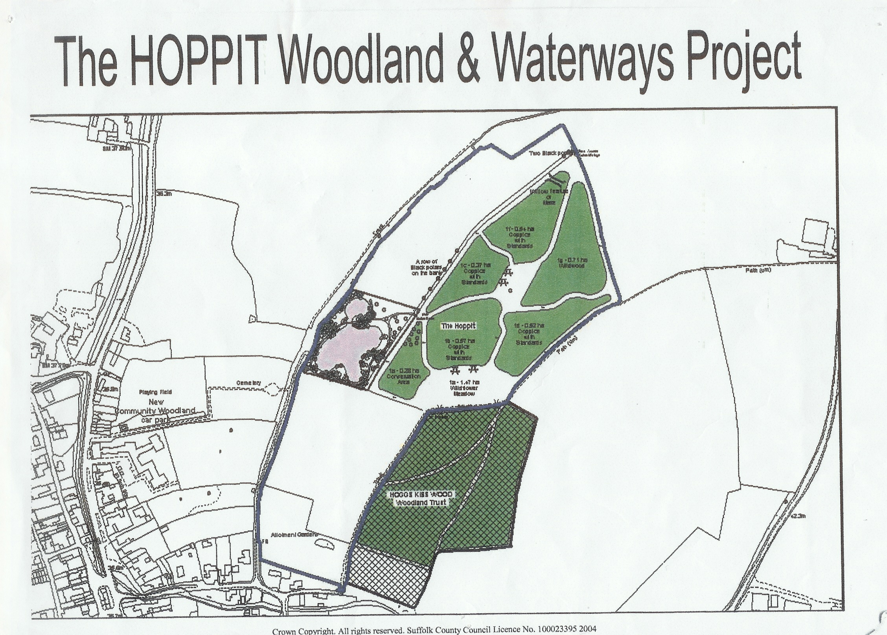
Figure 2 – Map of Wood and Lake

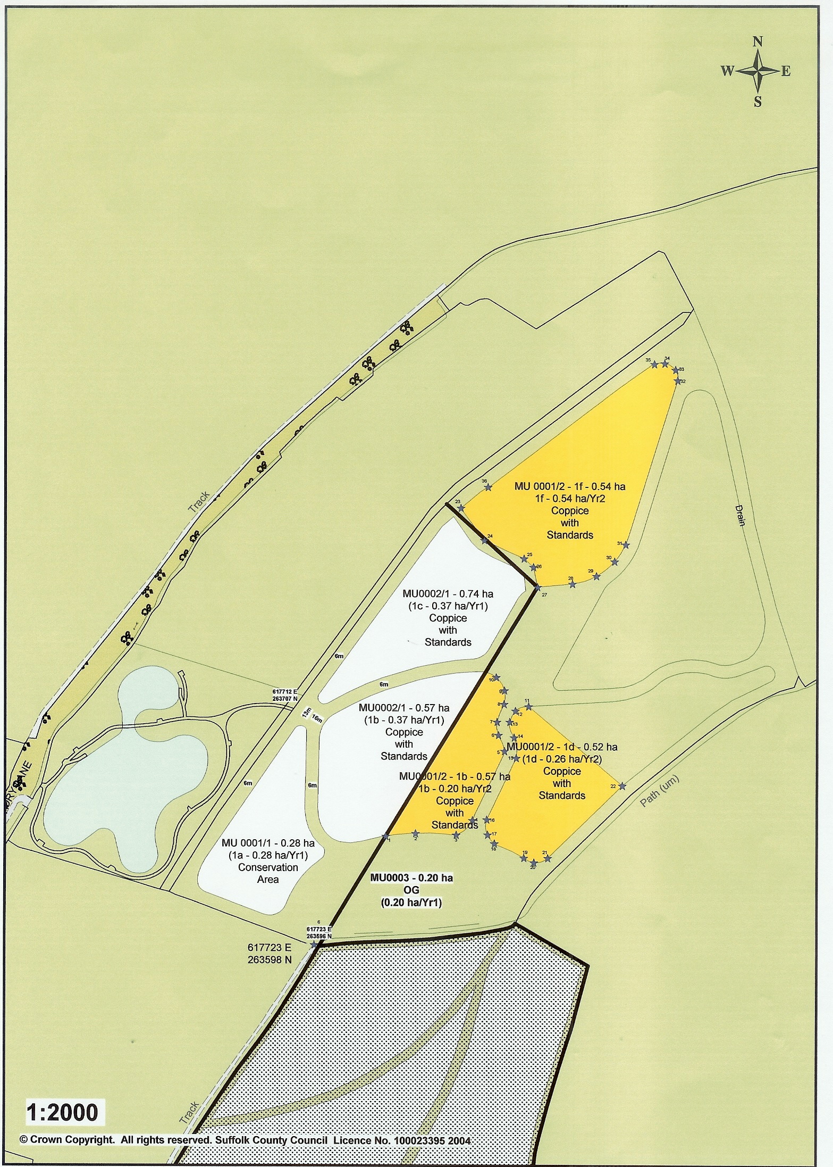

Figure 3 – Tree Planting

Child Protection Code of Conduct

Volunteers working with children on all Debenham Woodland and Lake.activities will:

• Treat all children with respect and dignity.
• Ensure that their welfare and safety is paramount at all times.
• Always act in a responsible way and not accept bullying, swearing or other disruptive behaviour.
• Liaise openly with parents and carers.
• Only use physical contact if absolutely necessary.
• Avoid being alone with children at all times.
• Ensure there is a good ratio of adult leaders to children i.e. 1 to 8
• Not directly supervise children under 9 years.
• Encourage volunteers to have a Criminal Records Bureau check. Contact your local Authority or your local Volunteer Bureau for information.
• Listen to, and act upon, any disclosures/allegations/concerns of child abuse, seeking advice from Social Services
• Attend training relating to child protection if appropriate
• Obtain written consent from a parent or guardian for children under 16, to cover:

Health and Safety

All Community-owned Woodland (CW) projects need to have a Health & Safety policy to protect volunteers, helpers and organisers from risks and hazards.

The Steering Group (SG) is responsible for the provision and maintenance of:
• Safe working areas.
• Safe facilities and equipment along with safe working techniques.
• Information and instruction to help avoid hazards.

The filling in of simple forms called Risk Assessments will help to achieve these objectives.

Risk Assessments

When completed, these forms will assess the level of risks associated with your project’s events.

Both a Site Risk Assessment and an Activity Risk Assessment will need to be done in advance of all your activities.

The responsibility for Risk Assessments becomes slightly more complex when working with schools or visiting groups – and/or when working on property not owned by your project.

Schools and visiting parties

Schools and visiting parties are responsible for the safe arrival on site of their group and should take precautions to ensure the safety of their party. This may be in the form of a Risk Assessment or simply through common sense and/or advice from the local community policeman. An example is the ‘walk’ from the school to the site along a busy road or up a winding lane. This is not the responsibility of your SG. But it will doubtless be appreciated if your School Link person supports the school in organising this aspect of the project-linked activities.

School activities within the school grounds

Here, the Site Risk Assessment is the responsibility of the school or local authority. Your School Link person should check it out. But if unobtainable, it is advisable to do your own Site Assessment.

As above, the Activity Risk Assessment remains your responsibility. Most school activities should be covered by the ‘From Seed to Tree’ Programme Activity Risk Assessment.

Site safety

The owner or manager of the site is responsible for the area and should undertake and advise you of their Site Risk Assessment. They should also know and point out hazards which an on-site inspection would fail to reveal e.g. underground services.
However, the on site activities are still the responsibility of your event Leader as is the Activity Risk Assessment.

Health & Safety Demos

For all outdoor school activities, work parties and planting events you will need an identified Leader who will be expected to give a brief Health & Safety demo - highlighting all potential hazards and instructing volunteers in the use of tools and equipment. The Activity and Site Risk Assessments should be available for inspection by the volunteers.

First Aid

A First Aid Kit should always be carried on site for all activities and a responsible person be officially appointed to deal with any accidents. In the event of an accident or injury this should be noted in an accident-reporting book or on an event report form. (See Toolkit heading: ‘Event Report Form’ for an example that you might choose to use or adapt).

It is highly advisable but not essential for a SG member to take a first aid course.
For school events, the school should be responsible for First Aid. But your School Link person should confirm this and request that their appointed First Aid person be identified to all.

Children and Young People on site

It is recommend that:

• Adults avoid being out of sight of other adults, if working with one child only.
• Adults must ensure that any physical contact is necessary and appropriate.
• All Leaders apply for police checking (this can be a slow process). Your local authority is usually the first port of call for advice on this process.

In addition, when working with groups of children outside the school context, parents should give their written consent, phone numbers of all participants should be carried by the Event Leader and children under 9 years old should be accompanied by an adult.

If in doubt on any Health & Safety issues, please contact your Woodland Leader.

Use of Equipment

The following rules/guidelines should always be followed when using the specified tools/equipment.

Brushcutter – see specific brushcutter risk assessment.

Amendment Record

Issue Status | Version | Date | Actioned by | Description
Draft | A | 05/09/05 | Kevin Voller | 1st draft of this document

Document Review

This document has been reviewed and agreed by the Debenham Woodland and Waterways Steering Group.

Signed: |  | Signed:
Role: |  | Role:
Date: |  | Date:

