August 2020 report for the Thredling Division from Cllr Matthew Hicks

Suffolk CoronaWatch launches

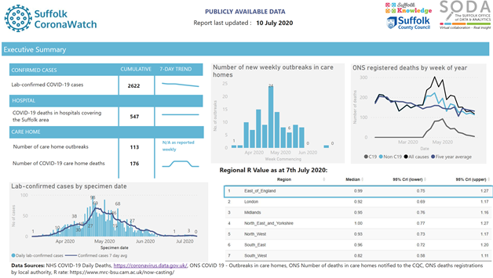

Suffolk’s Public Health Knowledge and Intelligence Team have produced a suite of resources called CoronaWatch. The online ‘Coronawatch’ dashboard, which launched in the week of 11 July, gathers all publicly available data on COVID-19 in Suffolk into one place. This data is in the public domain and free to access and use. You can visit the CoronaWatch dashboard at www.healthysuffolk.org.uk/jsna/coronawatch. You will be able to access national and local data, including confirmed cases of coronavirus (COVID-19), deaths from coronavirus, care home outbreaks, and Google social mobility data. You can also access a series of briefings which have been produced on related topics, all from publicly available sources.

Council proposes unprecedented environmental plans in response to climate emergency
In response to its declaration of a climate emergency, SCC aims to lead the way with an unparalleled range of activities and policy changes to support its ambition of being a ‘net zero’ authority by 2030. At its meeting on 14 July 2020, the council’s Cabinet reviewed and agreed an extensive programme of recommendations to achieve this ambition. The plans include dozens of changes and new ways of working, from making its pool car fleet all-electric, to making it mandatory for all future committee decisions to consider the net zero ambition. Being ‘net zero’ means that the council will remove its carbon emissions where it can; if it is unable to do so, it will compensate for those emissions. The council will adopt a more detailed method to measure its carbon emissions output, so that it can more accurately track its progress on an annual basis. SCC has been involved with successful climate change projects for many years, including the Suffolk Climate Change Partnership. Suffolk has been moving in the right direction, having seen carbon emission reductions of 41% since 1990. The impact of climate change is an issue which involves everyone and affects everyone. With the approval of these plans, the council will lead by example. With all local authorities in Suffolk having now declared a climate emergency, they will use their combined powers, duties, influence and leadership, continuing their work together to achieve the net zero ambition for emissions from all of Suffolk. Full details of the recommendations can be found : www.committeeminutes.suffolk.gov.uk/DocSetPage.aspx?MeetingTitle=(14-07-2020),%20The%20Cabinet
Next steps to improve the region’s rail service
A rail scheme to improve passenger rail service frequency between Ipswich/Norwich and Cambridge, and to provide a new direct rail service to Oxford, has moved a step closer with the commissioning of work to develop a business case for the Eastern Section of the East West Rail Main Line.
Consultants Steer have been appointed by the East West Rail Consortium, which has membership from local authorities across Suffolk, Norfolk, Cambridgeshire, Bedfordshire, Hertfordshire, Milton Keynes, Oxfordshire and Buckinghamshire, to develop a business case for enhancing rail connectivity. The business case will be used to demonstrate to the Department for Transport the economic benefit of improving the frequency of passenger rail services between Ipswich/Norwich and Cambridge (known as the Eastern Section of the East West Rail Main Line) and of providing a new direct passenger rail link from Suffolk/Norfolk to Oxford. If the business case is successful, the funding will be used to develop the next stage of the project, which is to assess the rail infrastructure requirements and develop a preferred rail infrastructure option. The East West Main Line will run from Oxford to Ipswich/Norwich via Cambridge and comprises three sections – Eastern Section (the existing line between Ipswich/Norwich and Cambridge), Central Section (a new rail route between Cambridge and Bedfordshire) and Western Section (a new rail route between Oxford and Bedfordshire). Both the Central Section and Western Section have received funding commitments from Government to construct new rail links. Although a new rail link is not needed on the Eastern Section, it is anticipated that rail infrastructure is required to improve the frequency of passenger rail services to Cambridge and onwards to Oxford.

Vans, trailers and trade waste now accepted at nine of Suffolk’s recycling centres
As of 1 July 2020, people with vans, trailers and trade waste can now book to visit 9 of Suffolk's 11 recycling centres. All visitors will need to pre-book an appointment online, where they will be asked what type of vehicle they will use and whether they are bringing household or business waste. To prevent queuing on neighbouring roads, people without a booking will not be able to enter the site. Social distancing measures also operate on site. Currently, appointments for vans, trailers and trade waste are unavailable at Haverhill and Leiston Recycling Centres. These are smaller sites and have fewer appointments available. There are a number of restrictions in place to help support social distancing at sites and to make sure waste is dealt with efficiently. These include:
Vans with trailers will not be allowed on all sites.
Only one visit per household or vehicle within seven days. This allows more visitors on site, while maintaining social distancing and protecting the health and safety of site staff and users.
Trailers must be no more than 750kg max gross weight, single axle and unbraked. No other trailer size or type is permitted. All waste should be pre-sorted to make your visit as quick and simple as possible and to maximise recycling.
The easy-to-use booking system is available at www.suffolk.gov.uk/recyclingcentres. If you do not have access to the internet call 0345 606 6067. Residents must not arrive on site more than five minutes before their allocated time. Appointments are released on a rolling seven-day basis.
Our phased response to reopening recycling centres since the lockdown has gone extremely well and we are grateful for the support of the public in allowing us to support social distancing on site, while still having the capacity to process the county’s waste. As part of this phased reopening, the Re-use shop at Bury St Edmunds reopened on Thursday 9 July, after the successful reopening of the Re-use shop at Foxhall recycling centre. The Re-use shops at the Foxhall and Bury recycling centres were closed in March following the lockdown announcement. The Re-use shops at Foxhall and Bury are part of a partnership between Suffolk County Council, waste and recycling partner FCC Environment, and charity partner The Benjamin Foundation. The shops were opened with the aim of reducing waste and increasing recycling in Suffolk, as well as raising vital funds for those in need.

Matthew Hicks - County Councillor for the Thredling Division
Tel : 01728 628176 Mob : 07824 474741 E-mail : matthew.hicks@suffolk.gov.uk

