2022 Annual Debenham Parish Meeting, Dove Cottage, Monday 23 May

Highlights from the last 12 months.
- Trading activity to financial year end 28 Feb 2022, in spite of Covid restrictions and limited use of Community Centre, was very positive.
- Bookings and sports activity in March and April are buoyant. The Deben Lounge is very busy at evenings and weekends.
- GP referral scheme is developing very successfully and will soon extend to offer Cardiac Rehabilitation. Feedback has been very complimentary.
- Rear car park has been completed, and rainwater drainage issue at the front have been resolved.
- New CCTV installation has been completed.
- All new logo, signage and website.
- New fire and intruder alarm system is currently being installed.
- Community Centre Bar has been refurbished.
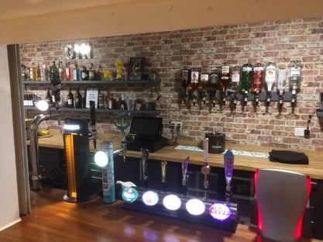
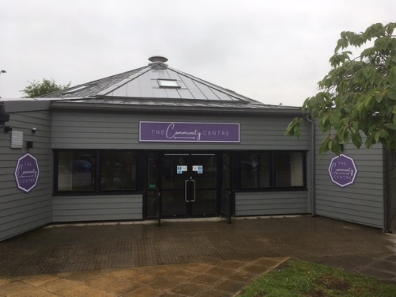
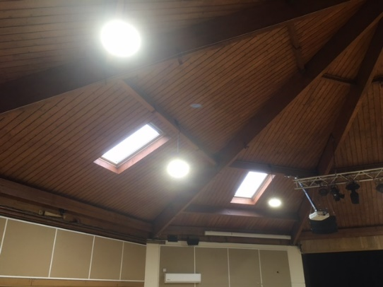
- External refurbishment of Community Centre has been completed.

New zinc roof, insulation, external cladding, heaters, external windows and doors, and new extended storage area.
Future plans;
- Refurbish Community Centre Toilets. Quotes have been obtained and funding bids have been submitted.
- Refurbishment of Sports Centre showers and changing facilities subject to funding support from FA. Initial enquiries are underway.
- Disabled access to Fitness Suite and Dance Studio.
DVH&PFT acknowledges the great support from Debenham Parish Council and BMSDC
Phil Jaynes
Treasurer DVH&PFT
May 2022

